**IL PADRE NOSTRO ILLUSTRATOC:\Users\Pavillon dv6\AppData\Local\Microsoft\Windows\Temporary Internet Files\Content.IE5\8EY3SD4K\j0435805[1].wmfC:\Users\Pavillon dv6\AppData\Local\Microsoft\Windows\Temporary Internet Files\Content.IE5\8EY3SD4K\j0435805[1].wmf**

**C:\Users\Pavillon dv6\AppData\Local\Microsoft\Windows\Temporary Internet Files\Content.IE5\8EY3SD4K\j0435805[1].wmfC:\Users\Pavillon dv6\AppData\Local\Microsoft\Windows\Temporary Internet Files\Content.IE5\8EY3SD4K\j0435805[1].wmf**

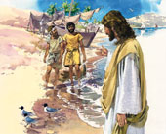**Padre nostro, che sei**

**nei cieli:**

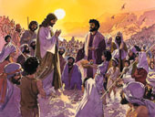

**Sia santificato il tuo nome.**

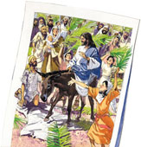

**Venga il tuo regno.**

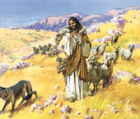

**Sia fatta la tua volontà, come in cielo così in terra.**

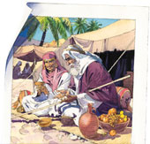

**C:\Users\Pavillon dv6\AppData\Local\Microsoft\Windows\Temporary Internet Files\Content.IE5\8EY3SD4K\j0435805[1].wmfC:\Users\Pavillon dv6\AppData\Local\Microsoft\Windows\Temporary Internet Files\Content.IE5\8EY3SD4K\j0435805[1].wmfDacci oggi il nostro pane quotidiano**.

**C:\Users\Pavillon dv6\AppData\Local\Microsoft\Windows\Temporary Internet Files\Content.IE5\8EY3SD4K\j0435805[1].wmfC:\Users\Pavillon dv6\AppData\Local\Microsoft\Windows\Temporary Internet Files\Content.IE5\8EY3SD4K\j0435805[1].wmfC:\Users\Pavillon dv6\AppData\Local\Microsoft\Windows\Temporary Internet Files\Content.IE5\8EY3SD4K\j0435805[1].wmfC:\Users\Pavillon dv6\AppData\Local\Microsoft\Windows\Temporary Internet Files\Content.IE5\8EY3SD4K\j0435805[1].wmf**

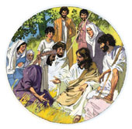

**E rimetti a noi i nostri debiti come noi li rimettiamo ai nostri debitori.**

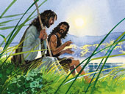

**E non ci indurre in tentazione.**

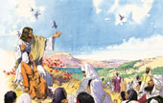

**Ma liberaci dal male. Amen.**

**C:\Users\Pavillon dv6\AppData\Local\Microsoft\Windows\Temporary Internet Files\Content.IE5\8EY3SD4K\j0435805[1].wmf**